DIGITAL IMAGE PROCESSING COURSE - 505060
PRACTICE LABS

LAB 03. BINARY IMAGE PROCESSING

Requirements
- Follow the instructions with the help from your instructor.
- Finish all the exercises in class and do the homework at home. You can update your solutions after class and re-submit all your work together with the homework.
- Grading
Total score = 50% * Attendance + 50% * Exercises
Rules:
- If the number of finished exercises is less than 80% total number of exercises, you will get zero for the lab, >= 80% -> 0.25 points, 100% -> 0.5 points
- Create a single source file Lab03_StudentID.ipynb. In the table of contents, name each section with a corresponding exercise number, for example Exercise 3.
- Add the text of your Student ID to each of the output images.
- Output images should be included in the notebook (ipynb) by running the Python code cells, the input images should be shown there too.
- Submit the ipynb file directly to Google classroom assignment, do not compress the files.
If you submit the exercises with wrong rules, you will get zero for the lab or the corresponding exercises.

- Plagiarism check
If any 2 of the students have the same output images, then all will get zero for the final score of the process evaluation 2 (practice class).

INTRODUCTION
In this Lab, you will learn how to
- Bitwise Operations
- Masking of images
- Alpha Blending with OpenCV
- Image thresholding

INSTRUCTIONS

- Bitwise Operations

OpenCV: Operations on arrays: bitwise_and()
dst = cv2.bitwise_and(src1, src2[, dst[, mask]])

cv2.bitwise_and() is a function that performs bitwise AND processing as the name suggests. The AND of the values for each pixel of the input images src1 and src2 is the pixel value of the output image.

Other Bitwise operation in Python (OR, XOR, NOT, SHIFT)

dst = cv2.bitwise_or(src1, src2[, dst[, mask]])
dst = cv2.bitwise_xor(src1, src2[, dst[, mask]])
dst = cv2.bitwise_not(src[, dst[, mask]])

Source: https://www.digitalocean.com/community/tutorials/arithmetic-bitwise-and-masking-python-opencv

Let’s create a bitwise square and a bitwise circle through which we can use the bitwise operations.

# creating a rectangle
rectangle = np.zeros((300, 300), dtype="uint8")
cv2.rectangle(rectangle, (25, 25), (275, 275), 255, -1)
cv2.imshow("Rectangle : ", rectangle)

# creating a circle
circle = np.zeros((300, 300), dtype="uint8")
cv2.circle(circle, (150, 150), 150, 255, -1)
cv2.imshow("Circle : ", circle)

# the bitwise_and function executes the AND operation
# on both the images
bitwiseAnd = cv2.bitwise_and(rectangle, circle)
cv2.imshow("AND", bitwiseAnd)
cv2.waitKey(0)

# the bitwise_or function executes the OR operation
# on both the images
bitwiseOr = cv2.bitwise_or(rectangle, circle)
cv2.imshow("OR", bitwiseOr)
cv2.waitKey(0)

# the bitwise_xor function executes the XOR operation
# on both the images
bitwiseXor = cv2.bitwise_xor(rectangle, circle)
cv2.imshow("XOR", bitwiseXor)
cv2.waitKey(0)

# the bitwise_not function executes the NOT operation
# on both the images
bitwiseNot = cv2.bitwise_not(rectangle, circle)
cv2.imshow("NOT", bitwiseNot)
cv2.waitKey(0)

- Masking of images
Masking is used in Image Processing to output the Region of Interest, or simply the part of the image that we are interested in. We tend to use bitwise operations for masking as it allows us to discard the parts of the image that we do not need.
We have three steps in masking.
- Creating a black canvas with the same dimensions as the image, and naming it as mask.
- Changing the values of the mask by drawing any figure in the image and providing it with a white color.
- Performing the bitwise AND operation on the image with the mask.

Example:
Masking with a rectangle mask.
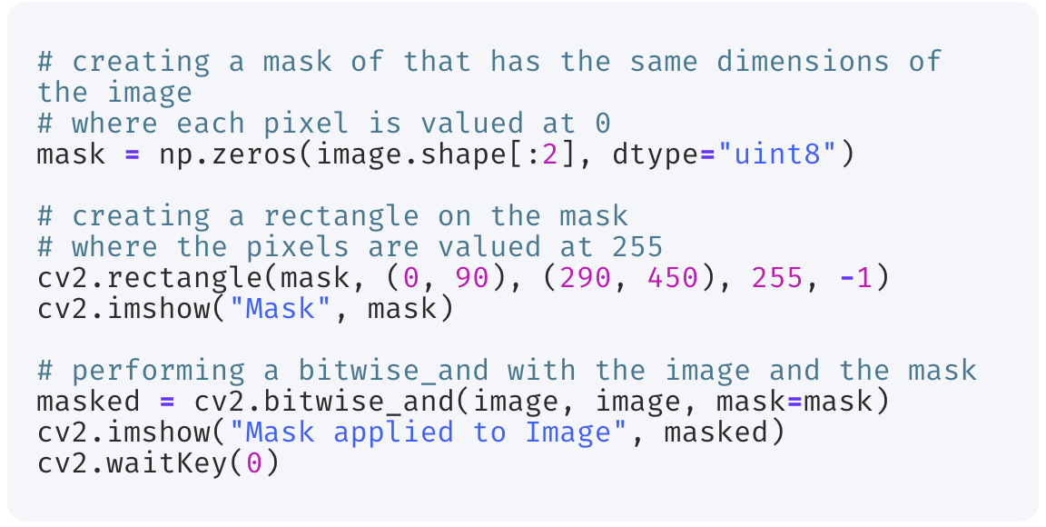
Masking with a circle mask.
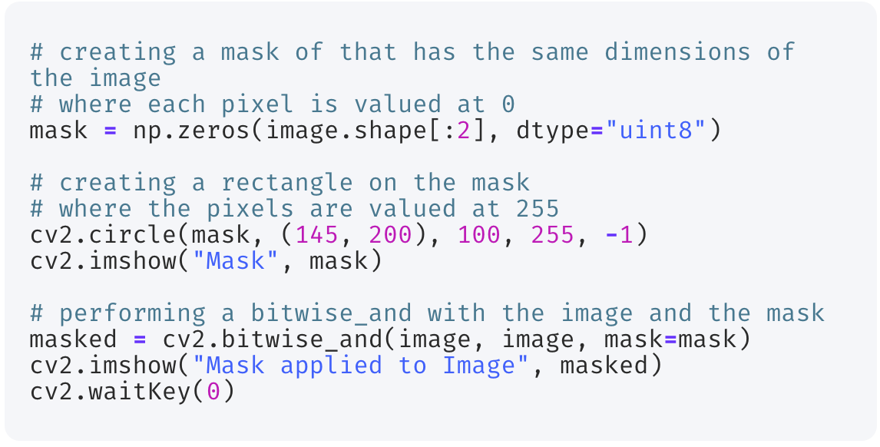

- Alpha Blending with OpenCV

Use cv2.addWeighted() to do alpha blending with OpenCV.

dst = cv2.addWeighted(src1, alpha, src2, beta, gamma[, dst[, dtype]])
It is calculated as follows according to parameters. The fifth parameter gamma is the value to be added to all pixel values.
dst = src1 * alpha + src2 * beta + gamma
The two images need to be the same size, so resize them.
import cv2
src1 = cv2.imread('lena.jpg')
src2 = cv2.imread('rocket.jpg')
src2 = cv2.resize(src2, src1.shape[1::-1])
The image is alpha blended according to the values of the second parameter alpha and the fourth parameter beta. Although images are saved as files here, if you want to display them in another window, you can use cv2.imshow() (eg: cv2.imshow('window_name', dst)). The same is true for the following sample code.
dst = cv2.addWeighted(src1, 0.5, src2, 0.5, 0)
cv2.imwrite('opencv_add_weighted.jpg', dst)
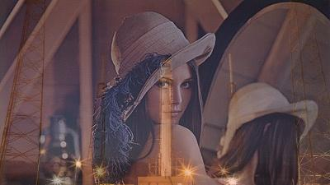
- Image thresholding
Image thresholding is a simple, yet effective, way of partitioning an image into a foreground and background. This image analysis technique is a type of image segmentation that isolates objects by converting grayscale images into binary images. Image thresholding is most effective in images with high levels of contrast.

The basic Thresholding technique is Binary Thresholding. For every pixel, the same threshold value is applied. If the pixel value is smaller than the threshold, it is set to 0, otherwise, it is set to a maximum value. The different Simple Thresholding Techniques are:

th, dst = cv2.threshold(source, thresholdValue, maxVal, thresholdingTechnique)

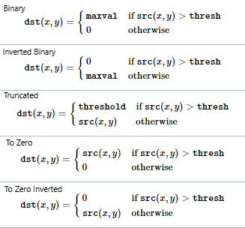
cv2.THRESH_BINARY
If pixel intensity is greater than the set threshold, value set to maxval, else set to 0 (black)

cv2.THRESH_BINARY_INV
Inverted case of cv2.THRESH_BINARY

cv.THRESH_TRUNC
If pixel intensity value is greater than threshold, it is truncated to the threshold. The pixel values are set to be the same as the threshold. All other values remain the same.

cv.THRESH_TOZERO
Pixel intensity is set to 0, for all the pixels intensity, less than the threshold value.

cv.THRESH_TOZERO_INV
Inverted case of cv2.THRESH_TOZERO.

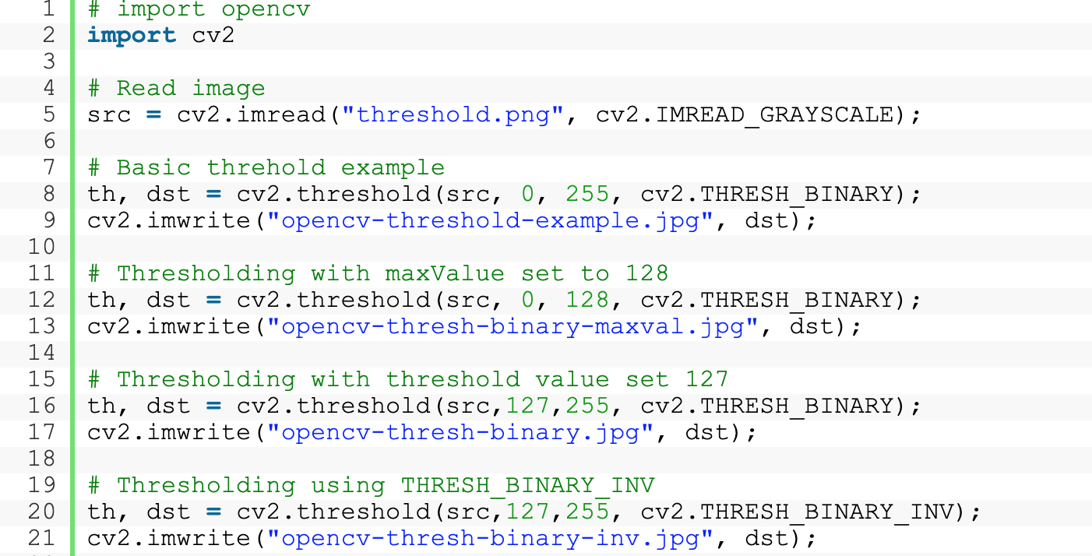
Source: https://learnopencv.com/opencv-threshold-python-cpp/

EXERCISE

Ex1. Masking image
Extracting the faces from the input image using a circular mask.
Output is 3 of face images extracted from the input image.
Hint: Using circular masks as in the instructions above.
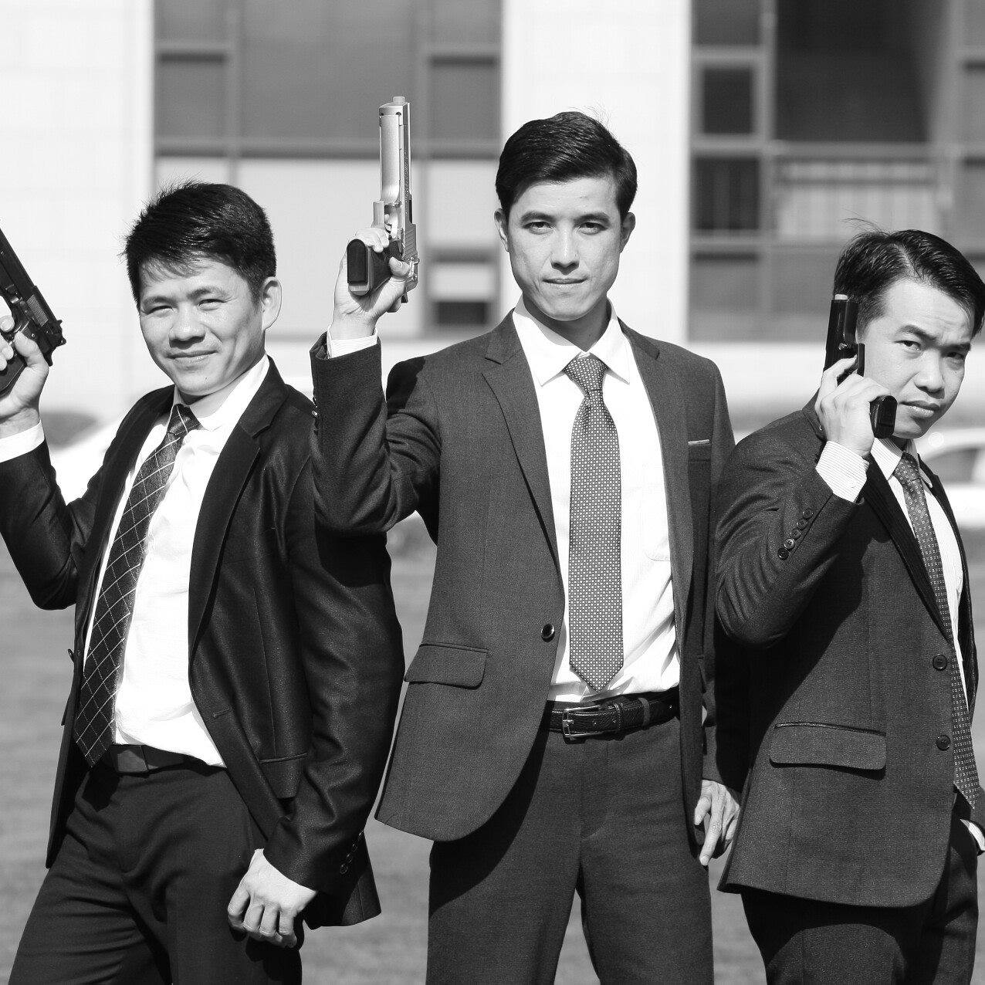

Ex2. Blend the following 2 images to create a new image


Ex3. Image thresholding
Given an input image as follows (numbers are pixel intensities)
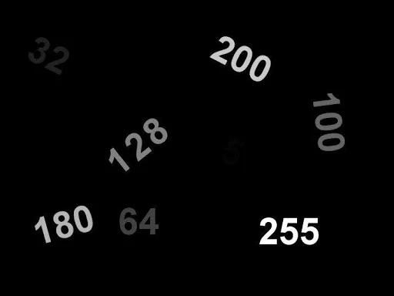

- Convert the image into 02 binary images:
  - 1st output : numbers greater than or equals to 180 are in black
  - 2nd output: numbers less than 180 are in white
Hints: Using different thresholds and binarization techniques.
- Extract each number in the input image as in separated images.

HOMEWORK

Create a video from your webcam by inserting the TDTU logo to images streaming from your webcam.

